**Bearing**

**No Aug**

**inception_v3**

Train: 100, Val: 96.80, Test: 95.40

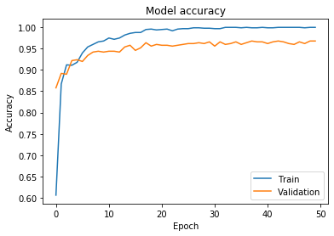 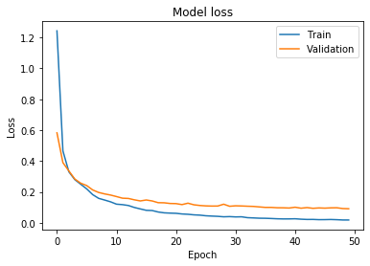

|  |  |  |  |  |  |  |  |  |  |
| --- | --- | --- | --- | --- | --- | --- | --- | --- | --- |
| 50 | 0 | 0 | 0 | 0 | 0 | 0 | 0 | 0 | 0 |
| 0 | 50 | 0 | 0 | 0 | 0 | 0 | 0 | 0 | 0 |
| 0 | 0 | 48 | 0 | 0 | 0 | 0 | 0 | 1 | 1 |
| 0 | 0 | 0 | 50 | 0 | 0 | 0 | 0 | 0 | 0 |
| 0 | 0 | 0 | 0 | 50 | 0 | 0 | 0 | 0 | 0 |
| 0 | 0 | 1 | 0 | 0 | 47 | 0 | 2 | 0 | 0 |
| 0 | 0 | 1 | 0 | 0 | 0 | 49 | 0 | 0 | 0 |
| 0 | 0 | 0 | 0 | 0 | 0 | 0 | 45 | 2 | 3 |
| 0 | 0 | 0 | 0 | 0 | 1 | 0 | 1 | 47 | 1 |
| 0 | 0 | 0 | 0 | 0 | 4 | 0 | 4 | 1 | 41 |

**Ensemble**

**inception_v3_Aug1**

Train: 100, Val: 97.4, Test: 96.40

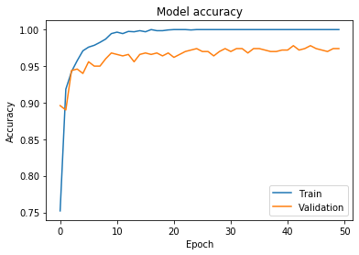 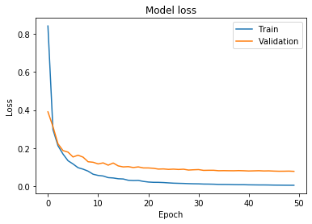

|  |  |  |  |  |  |  |  |  |  |
| --- | --- | --- | --- | --- | --- | --- | --- | --- | --- |
| 50 | 0 | 0 | 0 | 0 | 0 | 0 | 0 | 0 | 0 |
| 0 | 50 | 0 | 0 | 0 | 0 | 0 | 0 | 0 | 0 |
| 0 | 0 | 49 | 0 | 0 | 0 | 0 | 0 | 1 | 0 |
| 0 | 0 | 0 | 50 | 0 | 0 | 0 | 0 | 0 | 0 |
| 0 | 0 | 0 | 0 | 50 | 0 | 0 | 0 | 0 | 0 |
| 0 | 0 | 0 | 0 | 0 | 47 | 0 | 3 | 0 | 0 |
| 0 | 0 | 1 | 0 | 0 | 0 | 49 | 0 | 0 | 0 |
| 0 | 0 | 0 | 0 | 0 | 0 | 0 | 46 | 2 | 2 |
| 0 | 0 | 0 | 0 | 0 | 0 | 0 | 0 | 47 | 3 |
| 0 | 0 | 0 | 0 | 0 | 3 | 0 | 3 | 0 | 44 |

**inception_v3_Aug2**

Train: 100, Val: 97.2, Test: 96.40

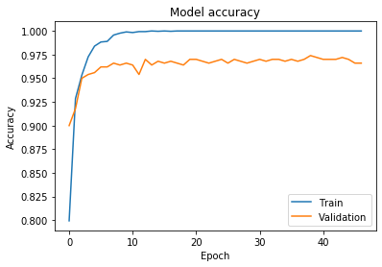 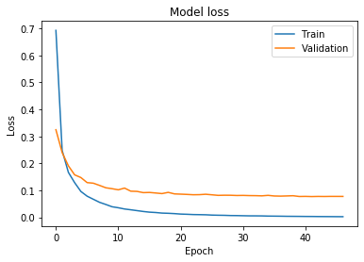

|  |  |  |  |  |  |  |  |  |  |
| --- | --- | --- | --- | --- | --- | --- | --- | --- | --- |
| 50 | 0 | 0 | 0 | 0 | 0 | 0 | 0 | 0 | 0 |
| 0 | 50 | 0 | 0 | 0 | 0 | 0 | 0 | 0 | 0 |
| 0 | 0 | 49 | 0 | 0 | 0 | 0 | 0 | 1 | 0 |
| 0 | 0 | 0 | 50 | 0 | 0 | 0 | 0 | 0 | 0 |
| 0 | 0 | 0 | 0 | 50 | 0 | 0 | 0 | 0 | 0 |
| 0 | 0 | 1 | 0 | 0 | 47 | 0 | 2 | 0 | 0 |
| 0 | 0 | 1 | 0 | 0 | 0 | 49 | 0 | 0 | 0 |
| 0 | 0 | 0 | 0 | 0 | 0 | 0 | 45 | 2 | 3 |
| 0 | 0 | 0 | 0 | 0 | 0 | 0 | 0 | 48 | 2 |
| 0 | 0 | 0 | 0 | 0 | 3 | 0 | 3 | 0 | 44 |

**inception_v3_Aug3**

Train: 100, Val: 97.4, Test: 96.4

 

|  |  |  |  |  |  |  |  |  |  |
| --- | --- | --- | --- | --- | --- | --- | --- | --- | --- |
| 50 | 0 | 0 | 0 | 0 | 0 | 0 | 0 | 0 | 0 |
| 0 | 50 | 0 | 0 | 0 | 0 | 0 | 0 | 0 | 0 |
| 0 | 0 | 49 | 0 | 0 | 0 | 0 | 0 | 1 | 0 |
| 0 | 0 | 0 | 50 | 0 | 0 | 0 | 0 | 0 | 0 |
| 0 | 0 | 0 | 0 | 50 | 0 | 0 | 0 | 0 | 0 |
| 0 | 0 | 1 | 0 | 0 | 47 | 0 | 2 | 0 | 0 |
| 0 | 0 | 1 | 0 | 0 | 0 | 49 | 0 | 0 | 0 |
| 0 | 0 | 0 | 0 | 0 | 0 | 0 | 45 | 2 | 3 |
| 0 | 0 | 0 | 0 | 0 | 0 | 0 | 0 | 48 | 2 |
| 0 | 0 | 0 | 0 | 0 | 3 | 0 | 3 | 0 | 44 |

**inception_v3_Aug4**

Train: 100, Val: 97.4, Test: 96.40

 

|  |  |  |  |  |  |  |  |  |  |
| --- | --- | --- | --- | --- | --- | --- | --- | --- | --- |
| 50 | 0 | 0 | 0 | 0 | 0 | 0 | 0 | 0 | 0 |
| 0 | 50 | 0 | 0 | 0 | 0 | 0 | 0 | 0 | 0 |
| 0 | 0 | 49 | 0 | 0 | 0 | 0 | 0 | 1 | 0 |
| 0 | 0 | 0 | 50 | 0 | 0 | 0 | 0 | 0 | 0 |
| 0 | 0 | 0 | 0 | 50 | 0 | 0 | 0 | 0 | 0 |
| 0 | 0 | 1 | 0 | 0 | 47 | 0 | 2 | 0 | 0 |
| 0 | 0 | 1 | 0 | 0 | 0 | 49 | 0 | 0 | 0 |
| 0 | 0 | 0 | 0 | 0 | 0 | 0 | 45 | 2 | 3 |
| 0 | 0 | 0 | 0 | 0 | 0 | 0 | 0 | 48 | 2 |
| 0 | 0 | 1 | 0 | 0 | 2 | 0 | 3 | 0 | 44 |

**inception_v3_Aug5**

Train: 100, Val: 97.60 Test: 96.20

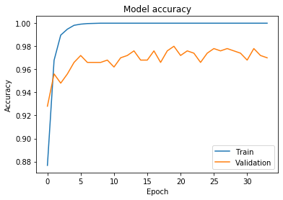 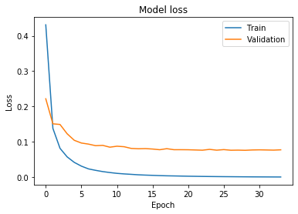

|  |  |  |  |  |  |  |  |  |  |
| --- | --- | --- | --- | --- | --- | --- | --- | --- | --- |
| 50 | 0 | 0 | 0 | 0 | 0 | 0 | 0 | 0 | 0 |
| 0 | 50 | 0 | 0 | 0 | 0 | 0 | 0 | 0 | 0 |
| 0 | 0 | 49 | 0 | 0 | 0 | 0 | 0 | 1 | 0 |
| 0 | 0 | 0 | 50 | 0 | 0 | 0 | 0 | 0 | 0 |
| 0 | 0 | 0 | 0 | 50 | 0 | 0 | 0 | 0 | 0 |
| 0 | 0 | 1 | 0 | 0 | 47 | 0 | 2 | 0 | 0 |
| 0 | 0 | 0 | 0 | 0 | 0 | 50 | 0 | 0 | 0 |
| 0 | 0 | 0 | 0 | 0 | 0 | 0 | 44 | 2 | 4 |
| 0 | 0 | 0 | 1 | 0 | 0 | 0 | 0 | 47 | 2 |
| 0 | 0 | 0 | 0 | 0 | 2 | 0 | 4 | 0 | 44 |

**inception_v3_Gan1**

Train: 99.80, Val: 96.80, Test: 94

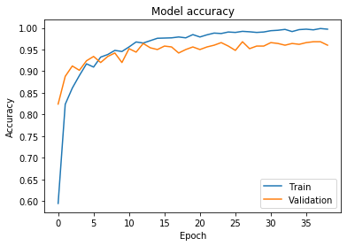 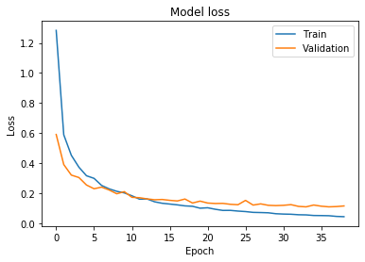

|  |  |  |  |  |  |  |  |  |  |
| --- | --- | --- | --- | --- | --- | --- | --- | --- | --- |
| 50 | 0 | 0 | 0 | 0 | 0 | 0 | 0 | 0 | 0 |
| 0 | 50 | 0 | 0 | 0 | 0 | 0 | 0 | 0 | 0 |
| 0 | 0 | 49 | 0 | 0 | 0 | 0 | 0 | 1 | 0 |
| 0 | 0 | 0 | 50 | 0 | 0 | 0 | 0 | 0 | 0 |
| 0 | 0 | 0 | 0 | 50 | 0 | 0 | 0 | 0 | 0 |
| 0 | 0 | 0 | 0 | 0 | 45 | 0 | 5 | 0 | 0 |
| 0 | 0 | 1 | 0 | 0 | 0 | 49 | 0 | 0 | 0 |
| 0 | 0 | 0 | 0 | 0 | 0 | 0 | 46 | 2 | 2 |
| 0 | 0 | 0 | 1 | 0 | 0 | 0 | 4 | 44 | 1 |
| 0 | 0 | 1 | 0 | 0 | 2 | 0 | 8 | 2 | 37 |

**inception_v3_Gan2**

Train: 99.68, Val: 95.80, Test: 95.20

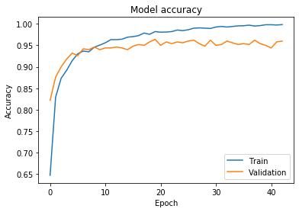 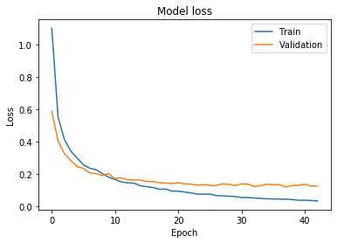

|  |  |  |  |  |  |  |  |  |  |
| --- | --- | --- | --- | --- | --- | --- | --- | --- | --- |
| 50 | 0 | 0 | 0 | 0 | 0 | 0 | 0 | 0 | 0 |
| 0 | 50 | 0 | 0 | 0 | 0 | 0 | 0 | 0 | 0 |
| 0 | 0 | 49 | 0 | 0 | 0 | 0 | 0 | 1 | 0 |
| 0 | 0 | 0 | 50 | 0 | 0 | 0 | 0 | 0 | 0 |
| 0 | 0 | 0 | 0 | 50 | 0 | 0 | 0 | 0 | 0 |
| 0 | 0 | 0 | 0 | 0 | 47 | 0 | 1 | 0 | 2 |
| 0 | 0 | 1 | 0 | 0 | 0 | 49 | 0 | 0 | 0 |
| 0 | 0 | 0 | 0 | 0 | 0 | 0 | 43 | 3 | 4 |
| 0 | 0 | 0 | 1 | 0 | 0 | 0 | 3 | 46 | 0 |
| 0 | 0 | 1 | 0 | 0 | 0 | 0 | 4 | 3 | 42 |

**inception_v3_Gan3**

Train: 99.08, Val: 96, Test: 94.4

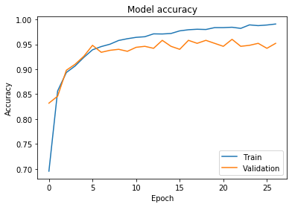 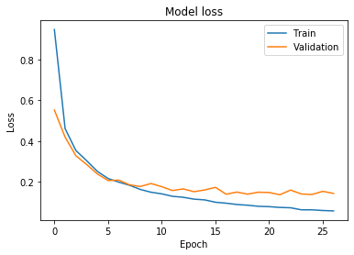

|  |  |  |  |  |  |  |  |  |  |
| --- | --- | --- | --- | --- | --- | --- | --- | --- | --- |
| 50 | 0 | 0 | 0 | 0 | 0 | 0 | 0 | 0 | 0 |
| 0 | 49 | 0 | 0 | 0 | 0 | 0 | 0 | 0 | 1 |
| 0 | 0 | 48 | 0 | 0 | 0 | 1 | 0 | 1 | 0 |
| 0 | 0 | 0 | 50 | 0 | 0 | 0 | 0 | 0 | 0 |
| 0 | 0 | 0 | 0 | 50 | 0 | 0 | 0 | 0 | 0 |
| 0 | 0 | 0 | 0 | 0 | 48 | 0 | 2 | 0 | 0 |
| 0 | 0 | 1 | 0 | 0 | 0 | 49 | 0 | 0 | 0 |
| 0 | 0 | 0 | 0 | 0 | 0 | 0 | 41 | 3 | 6 |
| 0 | 0 | 0 | 1 | 0 | 0 | 0 | 4 | 45 | 0 |
| 0 | 0 | 0 | 0 | 0 | 3 | 0 | 4 | 1 | 42 |

**inception_v3_Gan4**

Train: 98.70, Val: 95.80, Test: 94.6

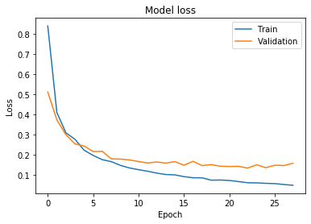 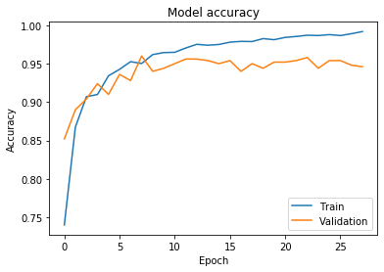

|  |  |  |  |  |  |  |  |  |  |
| --- | --- | --- | --- | --- | --- | --- | --- | --- | --- |
| 50 | 0 | 0 | 0 | 0 | 0 | 0 | 0 | 0 | 0 |
| 0 | 49 | 0 | 0 | 0 | 0 | 0 | 0 | 0 | 1 |
| 0 | 0 | 48 | 0 | 0 | 0 | 1 | 0 | 1 | 0 |
| 0 | 0 | 0 | 50 | 0 | 0 | 0 | 0 | 0 | 0 |
| 0 | 0 | 0 | 0 | 50 | 0 | 0 | 0 | 0 | 0 |
| 0 | 0 | 0 | 0 | 0 | 47 | 0 | 2 | 0 | 1 |
| 0 | 0 | 1 | 0 | 0 | 0 | 49 | 0 | 0 | 0 |
| 0 | 0 | 0 | 0 | 0 | 0 | 0 | 41 | 2 | 7 |
| 0 | 0 | 0 | 1 | 0 | 1 | 0 | 3 | 45 | 0 |
| 0 | 0 | 0 | 0 | 0 | 0 | 0 | 5 | 1 | 44 |

**inception_v3_Gan5**

Train: 98.9, Val: 95.0, Test: 94.6

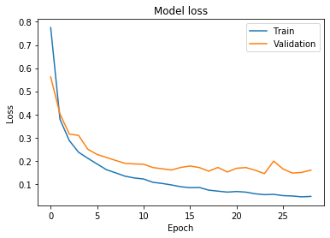 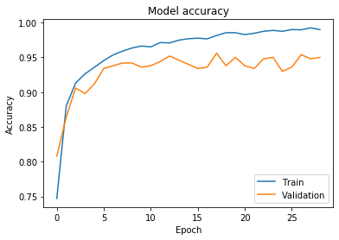

|  |  |  |  |  |  |  |  |  |  |
| --- | --- | --- | --- | --- | --- | --- | --- | --- | --- |
| 50 | 0 | 0 | 0 | 0 | 0 | 0 | 0 | 0 | 0 |
| 0 | 49 | 0 | 0 | 0 | 0 | 0 | 0 | 0 | 1 |
| 0 | 0 | 49 | 0 | 0 | 0 | 0 | 0 | 1 | 0 |
| 0 | 0 | 0 | 50 | 0 | 0 | 0 | 0 | 0 | 0 |
| 0 | 0 | 0 | 0 | 50 | 0 | 0 | 0 | 0 | 0 |
| 0 | 0 | 0 | 0 | 0 | 46 | 0 | 3 | 0 | 1 |
| 0 | 0 | 1 | 0 | 0 | 0 | 49 | 0 | 0 | 0 |
| 0 | 0 | 0 | 0 | 0 | 0 | 0 | 41 | 2 | 7 |
| 0 | 0 | 0 | 1 | 0 | 1 | 0 | 3 | 44 | 1 |
| 0 | 0 | 0 | 0 | 0 | 0 | 0 | 4 | 1 | 45 |

**mobilenet_v2**

**No Aug**

Train: 100, Val: 98.40, Test: 98

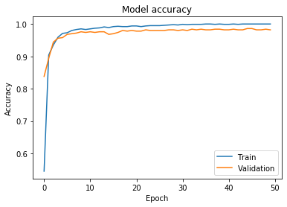 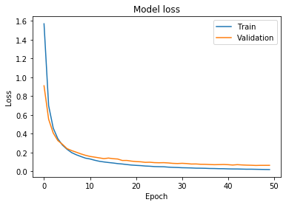

|  |  |  |  |  |  |  |  |  |  |
| --- | --- | --- | --- | --- | --- | --- | --- | --- | --- |
| 50 | 0 | 0 | 0 | 0 | 0 | 0 | 0 | 0 | 0 |
| 0 | 50 | 0 | 0 | 0 | 0 | 0 | 0 | 0 | 0 |
| 0 | 0 | 50 | 0 | 0 | 0 | 0 | 0 | 0 | 0 |
| 0 | 0 | 0 | 50 | 0 | 0 | 0 | 0 | 0 | 0 |
| 0 | 0 | 0 | 0 | 50 | 0 | 0 | 0 | 0 | 0 |
| 0 | 0 | 0 | 0 | 0 | 49 | 0 | 0 | 0 | 1 |
| 0 | 0 | 0 | 0 | 0 | 0 | 50 | 0 | 0 | 0 |
| 0 | 0 | 0 | 0 | 0 | 0 | 0 | 50 | 0 | 0 |
| 0 | 0 | 0 | 0 | 0 | 0 | 0 | 4 | 46 | 0 |
| 0 | 0 | 0 | 0 | 0 | 0 | 0 | 4 | 1 | 45 |

**mobilenet_v2_Aug1**

Train: 100, Val: 98.40, Test: 98.8

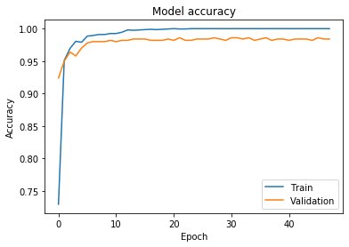 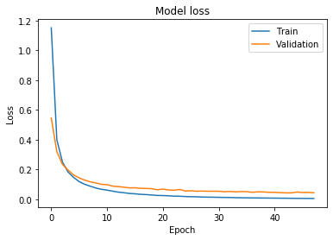

|  |  |  |  |  |  |  |  |  |  |
| --- | --- | --- | --- | --- | --- | --- | --- | --- | --- |
| 50 | 0 | 0 | 0 | 0 | 0 | 0 | 0 | 0 | 0 |
| 0 | 50 | 0 | 0 | 0 | 0 | 0 | 0 | 0 | 0 |
| 0 | 0 | 50 | 0 | 0 | 0 | 0 | 0 | 0 | 0 |
| 0 | 0 | 0 | 50 | 0 | 0 | 0 | 0 | 0 | 0 |
| 0 | 0 | 0 | 0 | 50 | 0 | 0 | 0 | 0 | 0 |
| 0 | 0 | 0 | 0 | 0 | 49 | 0 | 0 | 0 | 1 |
| 0 | 0 | 0 | 0 | 0 | 0 | 50 | 0 | 0 | 0 |
| 0 | 0 | 0 | 0 | 0 | 0 | 0 | 50 | 0 | 0 |
| 0 | 0 | 0 | 0 | 0 | 0 | 0 | 2 | 48 | 0 |
| 0 | 0 | 0 | 0 | 0 | 0 | 0 | 2 | 1 | 47 |

**mobilenet_v2 Aug2**

Train: 100, Val: 98.60, Test: 98.6

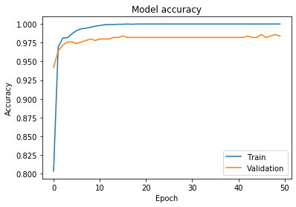 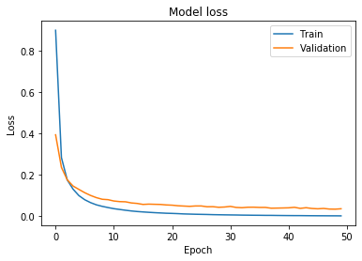

|  |  |  |  |  |  |  |  |  |  |
| --- | --- | --- | --- | --- | --- | --- | --- | --- | --- |
| 50 | 0 | 0 | 0 | 0 | 0 | 0 | 0 | 0 | 0 |
| 0 | 50 | 0 | 0 | 0 | 0 | 0 | 0 | 0 | 0 |
| 0 | 0 | 50 | 0 | 0 | 0 | 0 | 0 | 0 | 0 |
| 0 | 0 | 0 | 50 | 0 | 0 | 0 | 0 | 0 | 0 |
| 0 | 0 | 0 | 0 | 50 | 0 | 0 | 0 | 0 | 0 |
| 0 | 0 | 0 | 0 | 0 | 49 | 0 | 0 | 0 | 1 |
| 0 | 0 | 0 | 0 | 0 | 0 | 50 | 0 | 0 | 0 |
| 0 | 0 | 0 | 0 | 0 | 0 | 0 | 50 | 0 | 0 |
| 0 | 0 | 0 | 0 | 0 | 0 | 0 | 2 | 48 | 0 |
| 0 | 0 | 0 | 0 | 0 | 0 | 0 | 3 | 1 | 46 |

**mobilenet_v2 Aug3**

Train: 100, Val: 98.60, Test: 98.6

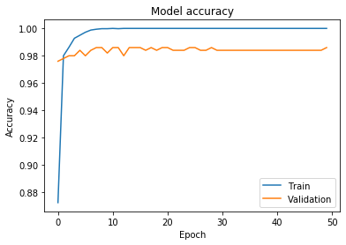 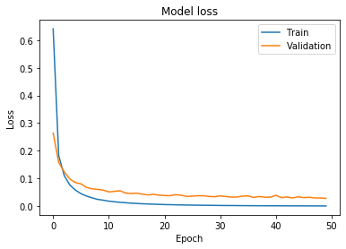

|  |  |  |  |  |  |  |  |  |  |
| --- | --- | --- | --- | --- | --- | --- | --- | --- | --- |
| 50 | 0 | 0 | 0 | 0 | 0 | 0 | 0 | 0 | 0 |
| 0 | 50 | 0 | 0 | 0 | 0 | 0 | 0 | 0 | 0 |
| 0 | 0 | 50 | 0 | 0 | 0 | 0 | 0 | 0 | 0 |
| 0 | 0 | 0 | 50 | 0 | 0 | 0 | 0 | 0 | 0 |
| 0 | 0 | 0 | 0 | 50 | 0 | 0 | 0 | 0 | 0 |
| 0 | 0 | 0 | 0 | 0 | 49 | 0 | 0 | 0 | 1 |
| 0 | 0 | 0 | 0 | 0 | 0 | 50 | 0 | 0 | 0 |
| 0 | 0 | 0 | 0 | 0 | 0 | 0 | 50 | 0 | 0 |
| 0 | 0 | 0 | 0 | 0 | 0 | 0 | 2 | 48 | 0 |
| 0 | 0 | 0 | 0 | 0 | 0 | 0 | 3 | 1 | 46 |

**mobilenet_v2 Aug4**

Train: 100, Val: 98.60, Test: 98.6

 

|  |  |  |  |  |  |  |  |  |  |
| --- | --- | --- | --- | --- | --- | --- | --- | --- | --- |
| 50 | 0 | 0 | 0 | 0 | 0 | 0 | 0 | 0 | 0 |
| 0 | 50 | 0 | 0 | 0 | 0 | 0 | 0 | 0 | 0 |
| 0 | 0 | 50 | 0 | 0 | 0 | 0 | 0 | 0 | 0 |
| 0 | 0 | 0 | 50 | 0 | 0 | 0 | 0 | 0 | 0 |
| 0 | 0 | 0 | 0 | 50 | 0 | 0 | 0 | 0 | 0 |
| 0 | 0 | 0 | 0 | 0 | 49 | 0 | 0 | 0 | 1 |
| 0 | 0 | 0 | 0 | 0 | 0 | 50 | 0 | 0 | 0 |
| 0 | 0 | 0 | 0 | 0 | 0 | 0 | 50 | 0 | 0 |
| 0 | 0 | 0 | 0 | 0 | 0 | 0 | 2 | 48 | 0 |
| 0 | 0 | 0 | 0 | 0 | 0 | 0 | 3 | 1 | 46 |

**mobilenet_v2 Aug5**

Train: 100, Val: 98.60, Test: 98.6

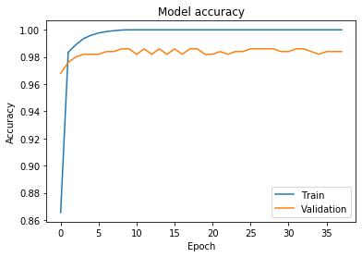 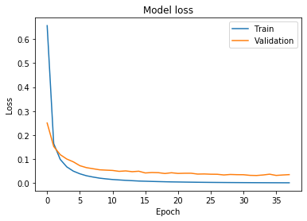

|  |  |  |  |  |  |  |  |  |  |
| --- | --- | --- | --- | --- | --- | --- | --- | --- | --- |
| 50 | 0 | 0 | 0 | 0 | 0 | 0 | 0 | 0 | 0 |
| 0 | 50 | 0 | 0 | 0 | 0 | 0 | 0 | 0 | 0 |
| 0 | 0 | 50 | 0 | 0 | 0 | 0 | 0 | 0 | 0 |
| 0 | 0 | 0 | 50 | 0 | 0 | 0 | 0 | 0 | 0 |
| 0 | 0 | 0 | 0 | 50 | 0 | 0 | 0 | 0 | 0 |
| 0 | 0 | 0 | 0 | 0 | 49 | 0 | 0 | 0 | 1 |
| 0 | 0 | 0 | 0 | 0 | 0 | 50 | 0 | 0 | 0 |
| 0 | 0 | 0 | 0 | 0 | 0 | 0 | 50 | 0 | 0 |
| 0 | 0 | 0 | 0 | 0 | 0 | 0 | 2 | 48 | 0 |
| 0 | 0 | 0 | 0 | 0 | 0 | 0 | 3 | 1 | 46 |

**mobilenet_v2 Gan1**

Train: 99.86, Val: 98.60, Test: 98.4

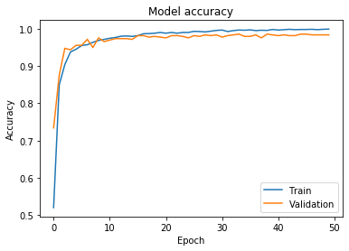 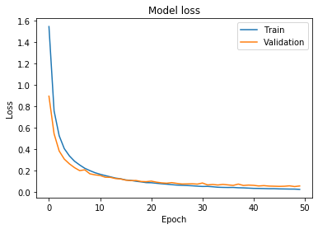

|  |  |  |  |  |  |  |  |  |  |
| --- | --- | --- | --- | --- | --- | --- | --- | --- | --- |
| 50 | 0 | 0 | 0 | 0 | 0 | 0 | 0 | 0 | 0 |
| 0 | 50 | 0 | 0 | 0 | 0 | 0 | 0 | 0 | 0 |
| 0 | 0 | 50 | 0 | 0 | 0 | 0 | 0 | 0 | 0 |
| 0 | 0 | 0 | 50 | 0 | 0 | 0 | 0 | 0 | 0 |
| 0 | 0 | 0 | 0 | 50 | 0 | 0 | 0 | 0 | 0 |
| 0 | 0 | 0 | 0 | 0 | 49 | 0 | 0 | 0 | 1 |
| 0 | 0 | 0 | 0 | 0 | 0 | 50 | 0 | 0 | 0 |
| 0 | 0 | 0 | 0 | 0 | 0 | 0 | 49 | 0 | 1 |
| 0 | 0 | 0 | 0 | 0 | 0 | 0 | 3 | 47 | 0 |
| 0 | 0 | 0 | 0 | 0 | 0 | 0 | 2 | 1 | 47 |

**mobilenet_v2 Gan2**

Train: 99.83, Val: 98.40, Test: 98.2

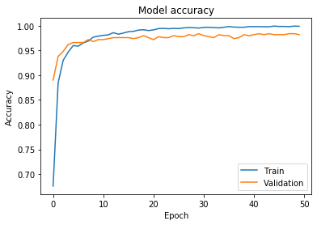 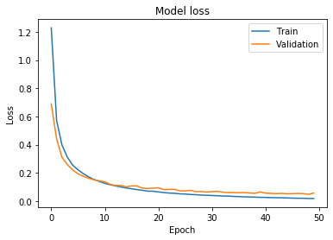

|  |  |  |  |  |  |  |  |  |  |
| --- | --- | --- | --- | --- | --- | --- | --- | --- | --- |
| 50 | 0 | 0 | 0 | 0 | 0 | 0 | 0 | 0 | 0 |
| 0 | 50 | 0 | 0 | 0 | 0 | 0 | 0 | 0 | 0 |
| 0 | 0 | 50 | 0 | 0 | 0 | 0 | 0 | 0 | 0 |
| 0 | 0 | 0 | 50 | 0 | 0 | 0 | 0 | 0 | 0 |
| 0 | 0 | 0 | 0 | 50 | 0 | 0 | 0 | 0 | 0 |
| 0 | 0 | 0 | 0 | 0 | 49 | 0 | 0 | 0 | 1 |
| 0 | 0 | 0 | 0 | 0 | 0 | 50 | 0 | 0 | 0 |
| 0 | 0 | 0 | 0 | 0 | 0 | 0 | 49 | 0 | 1 |
| 0 | 0 | 0 | 0 | 0 | 0 | 0 | 3 | 47 | 0 |
| 0 | 0 | 0 | 0 | 0 | 0 | 0 | 3 | 1 | 46 |

**mobilenet_v2 Gan3**

Train: 99.87, Val: 98.40, Test: 98

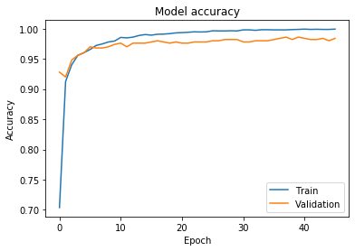 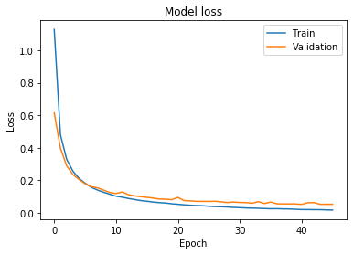

|  |  |  |  |  |  |  |  |  |  |
| --- | --- | --- | --- | --- | --- | --- | --- | --- | --- |
| 50 | 0 | 0 | 0 | 0 | 0 | 0 | 0 | 0 | 0 |
| 0 | 50 | 0 | 0 | 0 | 0 | 0 | 0 | 0 | 0 |
| 0 | 0 | 50 | 0 | 0 | 0 | 0 | 0 | 0 | 0 |
| 0 | 0 | 0 | 50 | 0 | 0 | 0 | 0 | 0 | 0 |
| 0 | 0 | 0 | 0 | 50 | 0 | 0 | 0 | 0 | 0 |
| 0 | 0 | 0 | 0 | 0 | 49 | 0 | 0 | 0 | 1 |
| 0 | 0 | 0 | 0 | 0 | 0 | 50 | 0 | 0 | 0 |
| 0 | 0 | 0 | 0 | 0 | 0 | 0 | 49 | 0 | 1 |
| 0 | 0 | 0 | 0 | 0 | 0 | 0 | 3 | 46 | 1 |
| 0 | 0 | 0 | 0 | 0 | 0 | 0 | 3 | 1 | 46 |

**mobilenet_v2 Gan4**

Train: 99.76, Val: 98.60, Test: 97.8

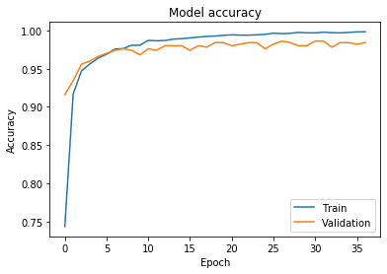 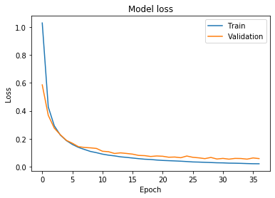

|  |  |  |  |  |  |  |  |  |  |
| --- | --- | --- | --- | --- | --- | --- | --- | --- | --- |
| 50 | 0 | 0 | 0 | 0 | 0 | 0 | 0 | 0 | 0 |
| 0 | 50 | 0 | 0 | 0 | 0 | 0 | 0 | 0 | 0 |
| 0 | 0 | 50 | 0 | 0 | 0 | 0 | 0 | 0 | 0 |
| 0 | 0 | 0 | 50 | 0 | 0 | 0 | 0 | 0 | 0 |
| 0 | 0 | 0 | 0 | 50 | 0 | 0 | 0 | 0 | 0 |
| 0 | 0 | 0 | 0 | 0 | 49 | 0 | 0 | 0 | 1 |
| 0 | 0 | 0 | 0 | 0 | 0 | 50 | 0 | 0 | 0 |
| 0 | 0 | 0 | 0 | 0 | 0 | 0 | 49 | 0 | 1 |
| 0 | 0 | 0 | 0 | 0 | 0 | 0 | 3 | 46 | 1 |
| 0 | 0 | 0 | 0 | 0 | 0 | 0 | 3 | 1 | 46 |

**mobilenet_v2 Gan5**

Train: 99.92, Val: 98.40, Test: 98.4

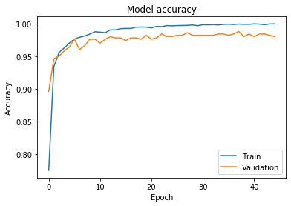 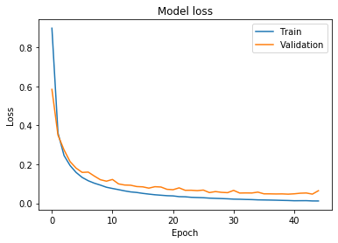

|  |  |  |  |  |  |  |  |  |  |
| --- | --- | --- | --- | --- | --- | --- | --- | --- | --- |
| 50 | 0 | 0 | 0 | 0 | 0 | 0 | 0 | 0 | 0 |
| 0 | 50 | 0 | 0 | 0 | 0 | 0 | 0 | 0 | 0 |
| 0 | 0 | 50 | 0 | 0 | 0 | 0 | 0 | 0 | 0 |
| 0 | 0 | 0 | 50 | 0 | 0 | 0 | 0 | 0 | 0 |
| 0 | 0 | 0 | 0 | 50 | 0 | 0 | 0 | 0 | 0 |
| 0 | 0 | 0 | 0 | 0 | 49 | 0 | 0 | 0 | 1 |
| 0 | 0 | 0 | 0 | 0 | 0 | 50 | 0 | 0 | 0 |
| 0 | 0 | 0 | 0 | 0 | 0 | 0 | 49 | 0 | 1 |
| 0 | 0 | 0 | 0 | 0 | 0 | 0 | 2 | 48 | 0 |
| 0 | 0 | 0 | 0 | 0 | 0 | 0 | 3 | 1 | 46 |

**ResNet 50**

Train: 100, Val: 99, Test: 98.4

|  |  |  |  |  |  |  |  |  |  |
| --- | --- | --- | --- | --- | --- | --- | --- | --- | --- |
| 50 | 0 | 0 | 0 | 0 | 0 | 0 | 0 | 0 | 0 |
| 0 | 50 | 0 | 0 | 0 | 0 | 0 | 0 | 0 | 0 |
| 0 | 0 | 50 | 0 | 0 | 0 | 0 | 0 | 0 | 0 |
| 0 | 0 | 0 | 50 | 0 | 0 | 0 | 0 | 0 | 0 |
| 0 | 0 | 0 | 0 | 50 | 0 | 0 | 0 | 0 | 0 |
| 0 | 0 | 0 | 0 | 0 | 50 | 0 | 0 | 0 | 0 |
| 0 | 0 | 1 | 0 | 0 | 0 | 49 | 0 | 0 | 0 |
| 0 | 0 | 0 | 0 | 0 | 0 | 0 | 48 | 1 | 1 |
| 0 | 0 | 0 | 1 | 0 | 0 | 0 | 2 | 47 | 0 |
| 0 | 0 | 0 | 0 | 0 | 0 | 0 | 2 | 0 | 48 |

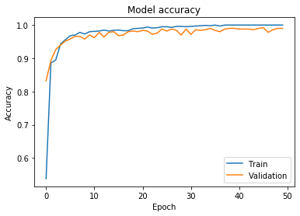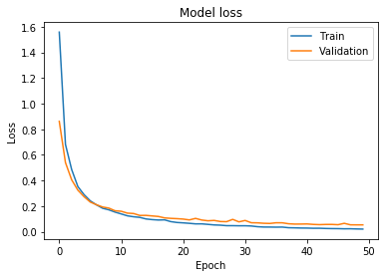

**ResNet 50_Aug1**

Train: 100, Val: 99, Test: 98.4

|  |  |  |  |  |  |  |  |  |  |
| --- | --- | --- | --- | --- | --- | --- | --- | --- | --- |
| 50 | 0 | 0 | 0 | 0 | 0 | 0 | 0 | 0 | 0 |
| 0 | 50 | 0 | 0 | 0 | 0 | 0 | 0 | 0 | 0 |
| 0 | 0 | 50 | 0 | 0 | 0 | 0 | 0 | 0 | 0 |
| 0 | 0 | 0 | 50 | 0 | 0 | 0 | 0 | 0 | 0 |
| 0 | 0 | 0 | 0 | 50 | 0 | 0 | 0 | 0 | 0 |
| 0 | 0 | 0 | 0 | 0 | 50 | 0 | 0 | 0 | 0 |
| 0 | 0 | 1 | 0 | 0 | 0 | 49 | 0 | 0 | 0 |
| 0 | 0 | 0 | 0 | 0 | 0 | 0 | 47 | 1 | 2 |
| 0 | 0 | 0 | 0 | 0 | 0 | 0 | 2 | 48 | 0 |
| 0 | 0 | 0 | 0 | 0 | 0 | 0 | 2 | 0 | 48 |

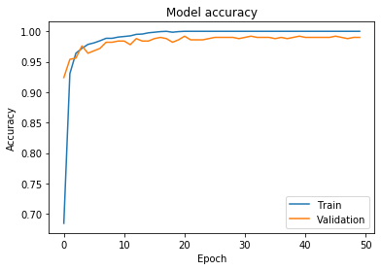 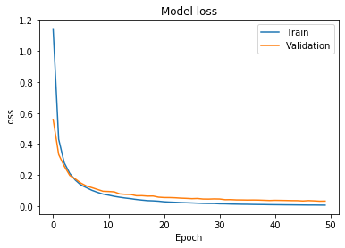

**ResNet 50_Aug2**

Train: 100, Val: 99.4, Test: 98.6

|  |  |  |  |  |  |  |  |  |  |
| --- | --- | --- | --- | --- | --- | --- | --- | --- | --- |
| 50 | 0 | 0 | 0 | 0 | 0 | 0 | 0 | 0 | 0 |
| 0 | 50 | 0 | 0 | 0 | 0 | 0 | 0 | 0 | 0 |
| 0 | 0 | 50 | 0 | 0 | 0 | 0 | 0 | 0 | 0 |
| 0 | 0 | 0 | 50 | 0 | 0 | 0 | 0 | 0 | 0 |
| 0 | 0 | 0 | 0 | 50 | 0 | 0 | 0 | 0 | 0 |
| 0 | 0 | 0 | 0 | 0 | 50 | 0 | 0 | 0 | 0 |
| 0 | 0 | 1 | 0 | 0 | 0 | 49 | 0 | 0 | 0 |
| 0 | 0 | 0 | 0 | 0 | 0 | 0 | 47 | 1 | 2 |
| 0 | 0 | 0 | 0 | 0 | 0 | 0 | 2 | 48 | 0 |
| 0 | 0 | 0 | 0 | 0 | 0 | 0 | 1 | 0 | 49 |

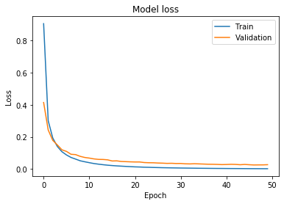 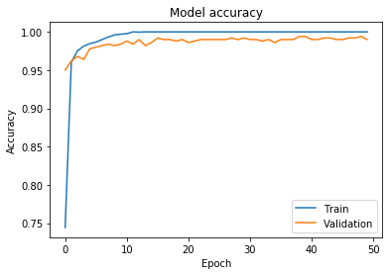

**ResNet 50_Aug3**

Train: 100, Val: 99.4, Test: 99.2

|  |  |  |  |  |  |  |  |  |  |
| --- | --- | --- | --- | --- | --- | --- | --- | --- | --- |
| 50 | 0 | 0 | 0 | 0 | 0 | 0 | 0 | 0 | 0 |
| 0 | 50 | 0 | 0 | 0 | 0 | 0 | 0 | 0 | 0 |
| 0 | 0 | 50 | 0 | 0 | 0 | 0 | 0 | 0 | 0 |
| 0 | 0 | 0 | 50 | 0 | 0 | 0 | 0 | 0 | 0 |
| 0 | 0 | 0 | 0 | 50 | 0 | 0 | 0 | 0 | 0 |
| 0 | 0 | 0 | 0 | 0 | 50 | 0 | 0 | 0 | 0 |
| 0 | 0 | 1 | 0 | 0 | 0 | 49 | 0 | 0 | 0 |
| 0 | 0 | 0 | 0 | 0 | 0 | 0 | 48 | 1 | 1 |
| 0 | 0 | 0 | 0 | 0 | 0 | 0 | 1 | 49 | 0 |
| 0 | 0 | 0 | 0 | 0 | 0 | 0 | 0 | 0 | 50 |

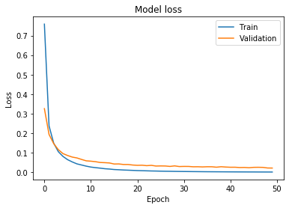 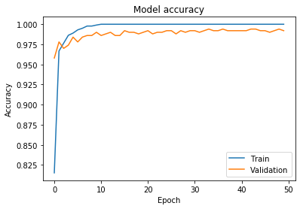

**ResNet 50_Aug4**

Train: 100, Val: 99.4, Test: 99.2

|  |  |  |  |  |  |  |  |  |  |
| --- | --- | --- | --- | --- | --- | --- | --- | --- | --- |
| 50 | 0 | 0 | 0 | 0 | 0 | 0 | 0 | 0 | 0 |
| 0 | 50 | 0 | 0 | 0 | 0 | 0 | 0 | 0 | 0 |
| 0 | 0 | 50 | 0 | 0 | 0 | 0 | 0 | 0 | 0 |
| 0 | 0 | 0 | 50 | 0 | 0 | 0 | 0 | 0 | 0 |
| 0 | 0 | 0 | 0 | 50 | 0 | 0 | 0 | 0 | 0 |
| 0 | 0 | 0 | 0 | 0 | 50 | 0 | 0 | 0 | 0 |
| 0 | 0 | 1 | 0 | 0 | 0 | 49 | 0 | 0 | 0 |
| 0 | 0 | 0 | 0 | 0 | 0 | 0 | 48 | 1 | 1 |
| 0 | 0 | 0 | 0 | 0 | 0 | 0 | 1 | 49 | 0 |
| 0 | 0 | 0 | 0 | 0 | 0 | 0 | 0 | 0 | 50 |

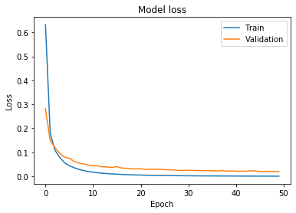 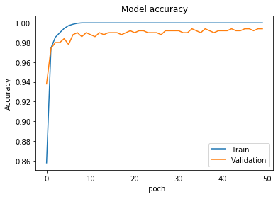

**ResNet 50_Aug5**

Train: 100, Val: 99.4, Test: 99

|  |  |  |  |  |  |  |  |  |  |
| --- | --- | --- | --- | --- | --- | --- | --- | --- | --- |
| 50 | 0 | 0 | 0 | 0 | 0 | 0 | 0 | 0 | 0 |
| 0 | 50 | 0 | 0 | 0 | 0 | 0 | 0 | 0 | 0 |
| 0 | 0 | 50 | 0 | 0 | 0 | 0 | 0 | 0 | 0 |
| 0 | 0 | 0 | 50 | 0 | 0 | 0 | 0 | 0 | 0 |
| 0 | 0 | 0 | 0 | 50 | 0 | 0 | 0 | 0 | 0 |
| 0 | 0 | 0 | 0 | 0 | 50 | 0 | 0 | 0 | 0 |
| 0 | 0 | 1 | 0 | 0 | 0 | 49 | 0 | 0 | 0 |
| 0 | 0 | 0 | 0 | 0 | 0 | 0 | 47 | 1 | 2 |
| 0 | 0 | 0 | 0 | 0 | 0 | 0 | 1 | 49 | 0 |
| 0 | 0 | 0 | 0 | 0 | 0 | 0 | 0 | 0 | 50 |

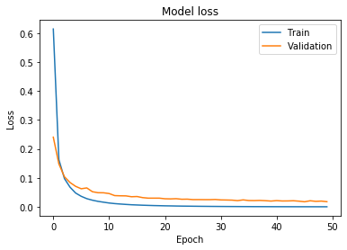 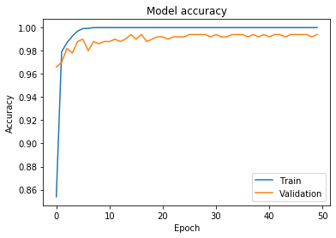

**ResNet 50_GAN1**

Train: 100, Val: 99.2, Test: 98

|  |  |  |  |  |  |  |  |  |  |
| --- | --- | --- | --- | --- | --- | --- | --- | --- | --- |
| 50 | 0 | 0 | 0 | 0 | 0 | 0 | 0 | 0 | 0 |
| 0 | 50 | 0 | 0 | 0 | 0 | 0 | 0 | 0 | 0 |
| 0 | 0 | 50 | 0 | 0 | 0 | 0 | 0 | 0 | 0 |
| 0 | 0 | 0 | 50 | 0 | 0 | 0 | 0 | 0 | 0 |
| 0 | 0 | 0 | 0 | 50 | 0 | 0 | 0 | 0 | 0 |
| 0 | 0 | 0 | 0 | 0 | 50 | 0 | 0 | 0 | 0 |
| 0 | 0 | 2 | 0 | 0 | 0 | 48 | 0 | 0 | 0 |
| 0 | 0 | 0 | 0 | 0 | 0 | 0 | 48 | 0 | 2 |
| 0 | 0 | 0 | 1 | 0 | 0 | 0 | 2 | 47 | 0 |
| 0 | 0 | 0 | 0 | 0 | 0 | 0 | 2 | 1 | 47 |

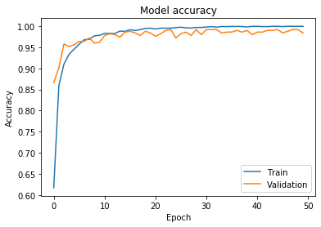 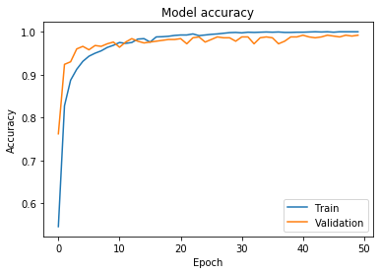

**ResNet 50_GAN2**

Train: 99.97, Val: 99.2, Test: 97.8

|  |  |  |  |  |  |  |  |  |  |
| --- | --- | --- | --- | --- | --- | --- | --- | --- | --- |
| 50 | 0 | 0 | 0 | 0 | 0 | 0 | 0 | 0 | 0 |
| 0 | 50 | 0 | 0 | 0 | 0 | 0 | 0 | 0 | 0 |
| 0 | 0 | 50 | 0 | 0 | 0 | 0 | 0 | 0 | 0 |
| 0 | 0 | 0 | 50 | 0 | 0 | 0 | 0 | 0 | 0 |
| 0 | 0 | 0 | 0 | 50 | 0 | 0 | 0 | 0 | 0 |
| 0 | 0 | 0 | 0 | 0 | 50 | 0 | 0 | 0 | 0 |
| 0 | 0 | 2 | 0 | 0 | 0 | 48 | 0 | 0 | 0 |
| 0 | 0 | 0 | 0 | 0 | 0 | 0 | 47 | 1 | 2 |
| 0 | 0 | 0 | 1 | 0 | 0 | 0 | 2 | 47 | 0 |
| 0 | 0 | 0 | 0 | 0 | 0 | 0 | 2 | 1 | 47 |

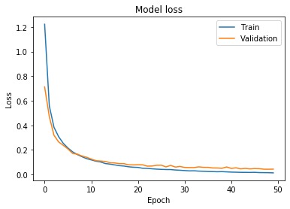 

**ResNet 50_GAN3**

Train: 99.80, Val: 98.80, Test: 98

|  |  |  |  |  |  |  |  |  |  |
| --- | --- | --- | --- | --- | --- | --- | --- | --- | --- |
| 50 | 0 | 0 | 0 | 0 | 0 | 0 | 0 | 0 | 0 |
| 0 | 50 | 0 | 0 | 0 | 0 | 0 | 0 | 0 | 0 |
| 0 | 0 | 50 | 0 | 0 | 0 | 0 | 0 | 0 | 0 |
| 0 | 0 | 0 | 50 | 0 | 0 | 0 | 0 | 0 | 0 |
| 0 | 0 | 0 | 0 | 50 | 0 | 0 | 0 | 0 | 0 |
| 0 | 0 | 0 | 0 | 0 | 50 | 0 | 0 | 0 | 0 |
| 0 | 0 | 2 | 0 | 0 | 0 | 48 | 0 | 0 | 0 |
| 0 | 0 | 0 | 0 | 0 | 0 | 0 | 48 | 0 | 2 |
| 0 | 0 | 0 | 1 | 0 | 1 | 0 | 2 | 46 | 0 |
| 0 | 0 | 0 | 0 | 0 | 0 | 0 | 2 | 0 | 48 |

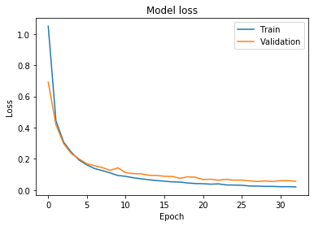 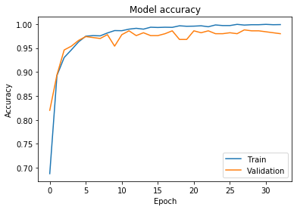

**ResNet 50_GAN4**

Train: 99.96, Val: 98.60, Test: 97.8

|  |  |  |  |  |  |  |  |  |  |
| --- | --- | --- | --- | --- | --- | --- | --- | --- | --- |
| 50 | 0 | 0 | 0 | 0 | 0 | 0 | 0 | 0 | 0 |
| 0 | 50 | 0 | 0 | 0 | 0 | 0 | 0 | 0 | 0 |
| 0 | 0 | 50 | 0 | 0 | 0 | 0 | 0 | 0 | 0 |
| 0 | 0 | 0 | 50 | 0 | 0 | 0 | 0 | 0 | 0 |
| 0 | 0 | 0 | 0 | 50 | 0 | 0 | 0 | 0 | 0 |
| 0 | 0 | 0 | 0 | 0 | 50 | 0 | 0 | 0 | 0 |
| 0 | 0 | 2 | 0 | 0 | 0 | 48 | 0 | 0 | 0 |
| 0 | 0 | 0 | 0 | 0 | 0 | 0 | 48 | 0 | 2 |
| 0 | 0 | 0 | 1 | 0 | 1 | 0 | 3 | 45 | 0 |
| 0 | 0 | 0 | 0 | 0 | 0 | 0 | 2 | 0 | 48 |

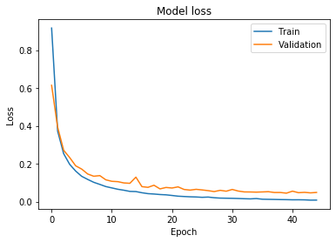 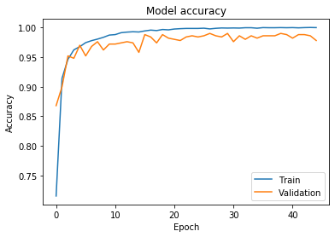

**ResNet 50_GAN4**

Train: 99.92, Val: 98.80, Test: 98.2

|  |  |  |  |  |  |  |  |  |  |
| --- | --- | --- | --- | --- | --- | --- | --- | --- | --- |
| 50 | 0 | 0 | 0 | 0 | 0 | 0 | 0 | 0 | 0 |
| 0 | 50 | 0 | 0 | 0 | 0 | 0 | 0 | 0 | 0 |
| 0 | 0 | 50 | 0 | 0 | 0 | 0 | 0 | 0 | 0 |
| 0 | 0 | 0 | 50 | 0 | 0 | 0 | 0 | 0 | 0 |
| 0 | 0 | 0 | 0 | 50 | 0 | 0 | 0 | 0 | 0 |
| 0 | 0 | 0 | 0 | 0 | 50 | 0 | 0 | 0 | 0 |
| 0 | 0 | 2 | 0 | 0 | 0 | 48 | 0 | 0 | 0 |
| 0 | 0 | 0 | 0 | 0 | 0 | 0 | 48 | 0 | 2 |
| 0 | 0 | 0 | 1 | 0 | 0 | 0 | 2 | 47 | 0 |
| 0 | 0 | 0 | 0 | 0 | 0 | 0 | 2 | 0 | 48 |

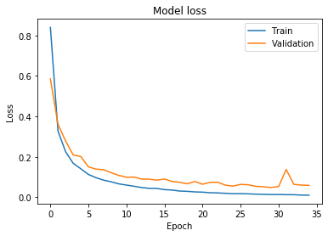 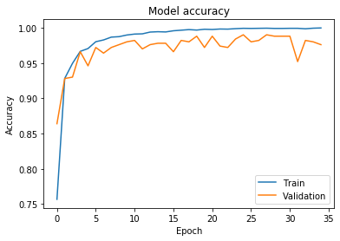

**ImageDataGen**

**inception_v3_horizontal_flip**

Train: 100, Val: 97.80, Test: 96.20

 

|  |  |  |  |  |  |  |  |  |  |
| --- | --- | --- | --- | --- | --- | --- | --- | --- | --- |
| 50 | 0 | 0 | 0 | 0 | 0 | 0 | 0 | 0 | 0 |
| 0 | 50 | 0 | 0 | 0 | 0 | 0 | 0 | 0 | 0 |
| 0 | 0 | 49 | 0 | 0 | 0 | 0 | 0 | 1 | 0 |
| 0 | 0 | 0 | 50 | 0 | 0 | 0 | 0 | 0 | 0 |
| 0 | 0 | 0 | 0 | 50 | 0 | 0 | 0 | 0 | 0 |
| 0 | 0 | 1 | 0 | 0 | 47 | 0 | 2 | 0 | 0 |
| 0 | 0 | 1 | 0 | 0 | 0 | 49 | 0 | 0 | 0 |
| 0 | 0 | 0 | 0 | 0 | 0 | 0 | 45 | 2 | 3 |
| 0 | 0 | 0 | 0 | 0 | 0 | 0 | 1 | 47 | 2 |
| 0 | 0 | 0 | 0 | 0 | 3 | 0 | 3 | 0 | 44 |

**inception_v3_vertical_flip**

Train: 100, Val: 97.20, Test: 95.6

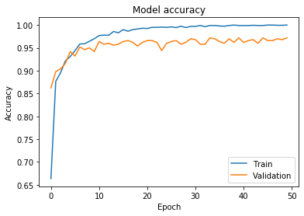 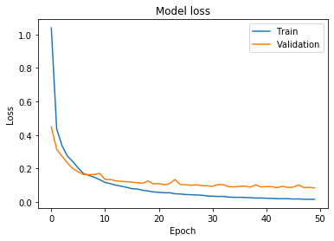

|  |  |  |  |  |  |  |  |  |  |
| --- | --- | --- | --- | --- | --- | --- | --- | --- | --- |
| 50 | 0 | 0 | 0 | 0 | 0 | 0 | 0 | 0 | 0 |
| 0 | 50 | 0 | 0 | 0 | 0 | 0 | 0 | 0 | 0 |
| 0 | 0 | 48 | 0 | 0 | 0 | 0 | 0 | 2 | 0 |
| 0 | 0 | 0 | 50 | 0 | 0 | 0 | 0 | 0 | 0 |
| 0 | 0 | 0 | 0 | 50 | 0 | 0 | 0 | 0 | 0 |
| 0 | 0 | 0 | 0 | 0 | 47 | 0 | 2 | 0 | 1 |
| 0 | 0 | 0 | 0 | 0 | 0 | 50 | 0 | 0 | 0 |
| 0 | 0 | 0 | 0 | 0 | 0 | 0 | 42 | 1 | 7 |
| 0 | 0 | 0 | 1 | 0 | 1 | 1 | 1 | 45 | 1 |
| 0 | 0 | 0 | 0 | 0 | 1 | 0 | 2 | 1 | 46 |

**inception_v3_width_shift**

Train: 100, Val: 97.40, Test: 96.2

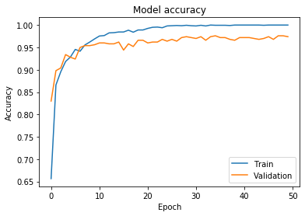 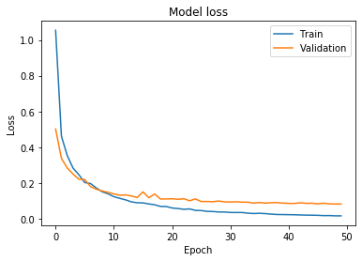

|  |  |  |  |  |  |  |  |  |  |
| --- | --- | --- | --- | --- | --- | --- | --- | --- | --- |
| 50 | 0 | 0 | 0 | 0 | 0 | 0 | 0 | 0 | 0 |
| 0 | 50 | 0 | 0 | 0 | 0 | 0 | 0 | 0 | 0 |
| 0 | 0 | 49 | 0 | 0 | 0 | 0 | 0 | 1 | 0 |
| 0 | 0 | 0 | 50 | 0 | 0 | 0 | 0 | 0 | 0 |
| 0 | 0 | 0 | 0 | 50 | 0 | 0 | 0 | 0 | 0 |
| 0 | 0 | 1 | 0 | 0 | 48 | 0 | 1 | 0 | 0 |
| 0 | 0 | 0 | 0 | 0 | 0 | 50 | 0 | 0 | 0 |
| 0 | 0 | 0 | 0 | 0 | 0 | 0 | 46 | 2 | 2 |
| 0 | 0 | 0 | 1 | 0 | 0 | 0 | 4 | 44 | 1 |
| 0 | 0 | 0 | 0 | 0 | 2 | 0 | 4 | 0 | 44 |

**inception_v3_height_shift**

Train: 98.90, Val: 96.8, Test: 94.8

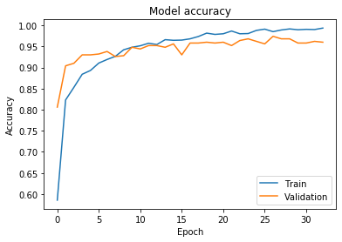 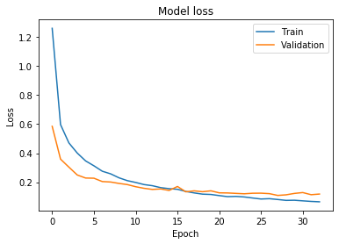

|  |  |  |  |  |  |  |  |  |  |
| --- | --- | --- | --- | --- | --- | --- | --- | --- | --- |
| 50 | 0 | 0 | 0 | 0 | 0 | 0 | 0 | 0 | 0 |
| 0 | 50 | 0 | 0 | 0 | 0 | 0 | 0 | 0 | 0 |
| 0 | 0 | 48 | 0 | 0 | 0 | 1 | 0 | 0 | 1 |
| 0 | 0 | 0 | 50 | 0 | 0 | 0 | 0 | 0 | 0 |
| 0 | 0 | 0 | 0 | 50 | 0 | 0 | 0 | 0 | 0 |
| 0 | 0 | 0 | 0 | 0 | 47 | 0 | 2 | 0 | 1 |
| 0 | 0 | 1 | 0 | 0 | 0 | 49 | 0 | 0 | 0 |
| 0 | 0 | 0 | 0 | 0 | 0 | 0 | 45 | 3 | 2 |
| 0 | 0 | 0 | 1 | 0 | 1 | 1 | 3 | 42 | 2 |
| 0 | 0 | 0 | 0 | 0 | 3 | 0 | 4 | 0 | 43 |

**inception_v3_rotation_shift**

Train: 99.50, Val: 97, Test: 95

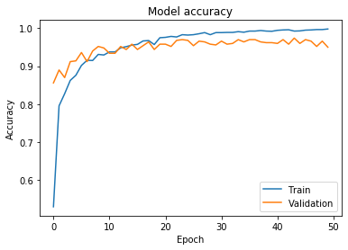 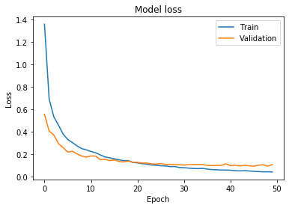

|  |  |  |  |  |  |  |  |  |  |
| --- | --- | --- | --- | --- | --- | --- | --- | --- | --- |
| 50 | 0 | 0 | 0 | 0 | 0 | 0 | 0 | 0 | 0 |
| 0 | 50 | 0 | 0 | 0 | 0 | 0 | 0 | 0 | 0 |
| 0 | 0 | 48 | 0 | 0 | 0 | 0 | 0 | 1 | 1 |
| 0 | 0 | 0 | 50 | 0 | 0 | 0 | 0 | 0 | 0 |
| 0 | 0 | 0 | 0 | 50 | 0 | 0 | 0 | 0 | 0 |
| 0 | 0 | 0 | 0 | 0 | 48 | 0 | 2 | 0 | 0 |
| 0 | 0 | 1 | 0 | 0 | 0 | 49 | 0 | 0 | 0 |
| 0 | 0 | 0 | 0 | 0 | 0 | 0 | 45 | 1 | 4 |
| 0 | 0 | 0 | 0 | 0 | 1 | 0 | 2 | 44 | 3 |
| 0 | 0 | 1 | 0 | 0 | 2 | 0 | 5 | 1 | 41 |

**inception_v3_brightness**

Train: 96, Val: 94, Test: 92.4

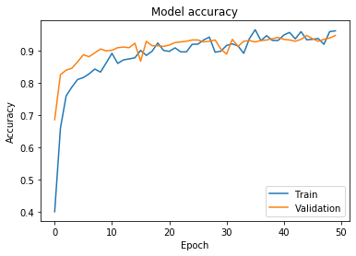 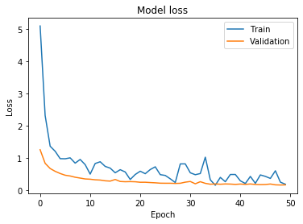

|  |  |  |  |  |  |  |  |  |  |
| --- | --- | --- | --- | --- | --- | --- | --- | --- | --- |
| 50 | 0 | 0 | 0 | 0 | 0 | 0 | 0 | 0 | 0 |
| 0 | 50 | 0 | 0 | 0 | 0 | 0 | 0 | 0 | 0 |
| 0 | 0 | 46 | 0 | 0 | 0 | 2 | 0 | 2 | 0 |
| 0 | 0 | 0 | 50 | 0 | 0 | 0 | 0 | 0 | 0 |
| 0 | 0 | 0 | 0 | 50 | 0 | 0 | 0 | 0 | 0 |
| 0 | 0 | 0 | 0 | 0 | 44 | 0 | 4 | 1 | 1 |
| 0 | 0 | 0 | 0 | 0 | 0 | 50 | 0 | 0 | 0 |
| 0 | 0 | 0 | 0 | 0 | 0 | 0 | 45 | 2 | 3 |
| 0 | 0 | 0 | 1 | 0 | 2 | 1 | 4 | 41 | 1 |
| 0 | 0 | 1 | 0 | 0 | 3 | 0 | 8 | 2 | 36 |

**inception_v3_zoom**

Train: 99.20, Val: 95.80, Test: 95.6

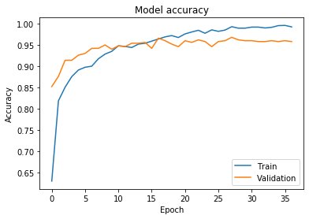 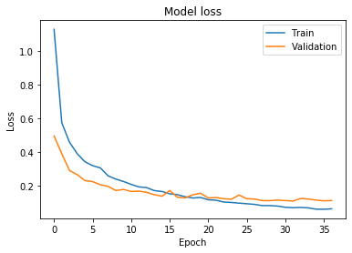

|  |  |  |  |  |  |  |  |  |  |
| --- | --- | --- | --- | --- | --- | --- | --- | --- | --- |
| 50 | 0 | 0 | 0 | 0 | 0 | 0 | 0 | 0 | 0 |
| 0 | 50 | 0 | 0 | 0 | 0 | 0 | 0 | 0 | 0 |
| 0 | 0 | 50 | 0 | 0 | 0 | 0 | 0 | 0 | 0 |
| 0 | 0 | 0 | 50 | 0 | 0 | 0 | 0 | 0 | 0 |
| 0 | 0 | 0 | 0 | 50 | 0 | 0 | 0 | 0 | 0 |
| 0 | 0 | 0 | 0 | 0 | 49 | 0 | 1 | 0 | 0 |
| 0 | 0 | 0 | 0 | 0 | 0 | 50 | 0 | 0 | 0 |
| 0 | 0 | 0 | 0 | 0 | 0 | 0 | 43 | 3 | 4 |
| 0 | 0 | 0 | 1 | 0 | 0 | 0 | 2 | 46 | 1 |
| 0 | 0 | 1 | 0 | 0 | 4 | 0 | 4 | 1 | 40 |

**inception_v3_shear**

Train: 99.95, Val: 96.40, Test: 95.2

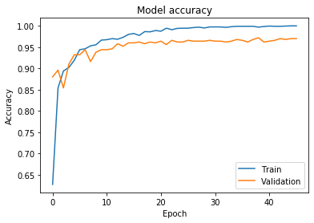 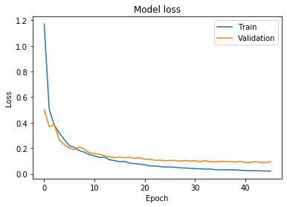

|  |  |  |  |  |  |  |  |  |  |
| --- | --- | --- | --- | --- | --- | --- | --- | --- | --- |
| 50 | 0 | 0 | 0 | 0 | 0 | 0 | 0 | 0 | 0 |
| 0 | 50 | 0 | 0 | 0 | 0 | 0 | 0 | 0 | 0 |
| 0 | 0 | 49 | 0 | 0 | 0 | 0 | 0 | 0 | 1 |
| 0 | 0 | 0 | 50 | 0 | 0 | 0 | 0 | 0 | 0 |
| 0 | 0 | 0 | 0 | 50 | 0 | 0 | 0 | 0 | 0 |
| 0 | 0 | 0 | 0 | 0 | 46 | 0 | 3 | 0 | 1 |
| 0 | 0 | 1 | 0 | 0 | 0 | 49 | 0 | 0 | 0 |
| 0 | 0 | 0 | 0 | 0 | 0 | 0 | 44 | 2 | 4 |
| 0 | 0 | 0 | 0 | 0 | 0 | 0 | 2 | 46 | 2 |
| 0 | 0 | 0 | 0 | 0 | 3 | 0 | 4 | 1 | 42 |

**ImageDataGen**

**mobilenet_v2_horizontal_flip**

Train: 100, Val: 98.6, Test: 98.8

 

|  |  |  |  |  |  |  |  |  |  |
| --- | --- | --- | --- | --- | --- | --- | --- | --- | --- |
| 50 | 0 | 0 | 0 | 0 | 0 | 0 | 0 | 0 | 0 |
| 0 | 50 | 0 | 0 | 0 | 0 | 0 | 0 | 0 | 0 |
| 0 | 0 | 50 | 0 | 0 | 0 | 0 | 0 | 0 | 0 |
| 0 | 0 | 0 | 50 | 0 | 0 | 0 | 0 | 0 | 0 |
| 0 | 0 | 0 | 0 | 50 | 0 | 0 | 0 | 0 | 0 |
| 0 | 0 | 0 | 0 | 0 | 49 | 0 | 0 | 0 | 1 |
| 0 | 0 | 0 | 0 | 0 | 0 | 50 | 0 | 0 | 0 |
| 0 | 0 | 0 | 0 | 0 | 0 | 0 | 50 | 0 | 0 |
| 0 | 0 | 0 | 0 | 0 | 0 | 0 | 2 | 48 | 0 |
| 0 | 0 | 0 | 0 | 0 | 0 | 0 | 2 | 1 | 47 |

**mobilenet_v2_vertical_flip**

Train: 99.95, Val: 98.20, Test: 97.8

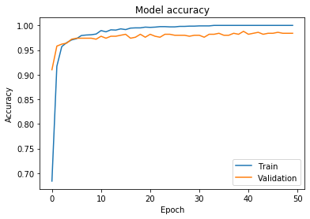 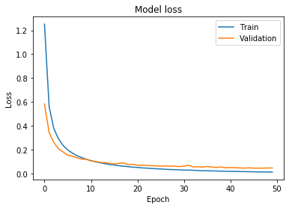

|  |  |  |  |  |  |  |  |  |  |
| --- | --- | --- | --- | --- | --- | --- | --- | --- | --- |
| 50 | 0 | 0 | 0 | 0 | 0 | 0 | 0 | 0 | 0 |
| 0 | 50 | 0 | 0 | 0 | 0 | 0 | 0 | 0 | 0 |
| 0 | 0 | 50 | 0 | 0 | 0 | 0 | 0 | 0 | 0 |
| 0 | 0 | 0 | 50 | 0 | 0 | 0 | 0 | 0 | 0 |
| 0 | 0 | 0 | 0 | 50 | 0 | 0 | 0 | 0 | 0 |
| 0 | 0 | 0 | 0 | 0 | 49 | 0 | 0 | 0 | 1 |
| 0 | 0 | 0 | 0 | 0 | 0 | 50 | 0 | 0 | 0 |
| 0 | 0 | 0 | 0 | 0 | 0 | 0 | 49 | 0 | 1 |
| 0 | 0 | 0 | 0 | 0 | 0 | 0 | 4 | 46 | 0 |
| 0 | 0 | 0 | 0 | 0 | 0 | 0 | 4 | 1 | 45 |

**mobilenet_v2_width_shift**

Train: 99.95, Val: 98.6, Test: 98.8

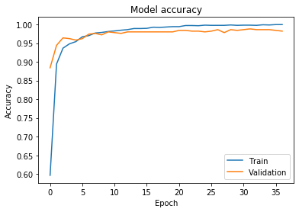 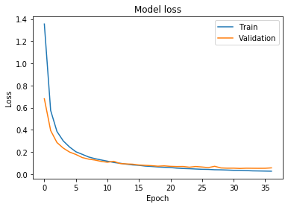

|  |  |  |  |  |  |  |  |  |  |
| --- | --- | --- | --- | --- | --- | --- | --- | --- | --- |
| 50 | 0 | 0 | 0 | 0 | 0 | 0 | 0 | 0 | 0 |
| 0 | 50 | 0 | 0 | 0 | 0 | 0 | 0 | 0 | 0 |
| 0 | 0 | 50 | 0 | 0 | 0 | 0 | 0 | 0 | 0 |
| 0 | 0 | 0 | 50 | 0 | 0 | 0 | 0 | 0 | 0 |
| 0 | 0 | 0 | 0 | 50 | 0 | 0 | 0 | 0 | 0 |
| 0 | 0 | 0 | 0 | 0 | 49 | 0 | 0 | 0 | 1 |
| 0 | 0 | 0 | 0 | 0 | 0 | 50 | 0 | 0 | 0 |
| 0 | 0 | 0 | 0 | 0 | 0 | 0 | 49 | 0 | 1 |
| 0 | 0 | 0 | 0 | 0 | 0 | 0 | 2 | 48 | 0 |
| 0 | 0 | 0 | 0 | 0 | 0 | 0 | 1 | 1 | 48 |

**mobilenet_v2_height_shift**

Train: 99.85, Val: 98.6, Test: 98

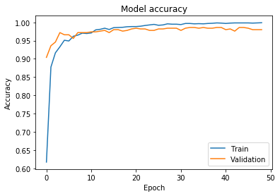 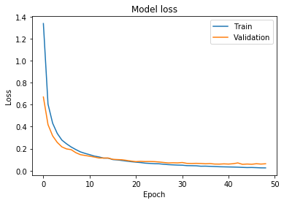

|  |  |  |  |  |  |  |  |  |  |
| --- | --- | --- | --- | --- | --- | --- | --- | --- | --- |
| 50 | 0 | 0 | 0 | 0 | 0 | 0 | 0 | 0 | 0 |
| 0 | 50 | 0 | 0 | 0 | 0 | 0 | 0 | 0 | 0 |
| 0 | 0 | 50 | 0 | 0 | 0 | 0 | 0 | 0 | 0 |
| 0 | 0 | 0 | 50 | 0 | 0 | 0 | 0 | 0 | 0 |
| 0 | 0 | 0 | 0 | 50 | 0 | 0 | 0 | 0 | 0 |
| 0 | 0 | 0 | 0 | 0 | 49 | 0 | 0 | 0 | 1 |
| 0 | 0 | 0 | 0 | 0 | 0 | 50 | 0 | 0 | 0 |
| 0 | 0 | 0 | 0 | 0 | 0 | 0 | 49 | 0 | 1 |
| 0 | 0 | 0 | 0 | 0 | 0 | 1 | 3 | 46 | 0 |
| 0 | 0 | 0 | 0 | 0 | 0 | 0 | 2 | 2 | 46 |

**mobilenet_v2_rotation_shift**

Train: 99.95, Val: 98.6, Test: 98.6

 

|  |  |  |  |  |  |  |  |  |  |
| --- | --- | --- | --- | --- | --- | --- | --- | --- | --- |
| 50 | 0 | 0 | 0 | 0 | 0 | 0 | 0 | 0 | 0 |
| 0 | 50 | 0 | 0 | 0 | 0 | 0 | 0 | 0 | 0 |
| 0 | 0 | 50 | 0 | 0 | 0 | 0 | 0 | 0 | 0 |
| 0 | 0 | 0 | 50 | 0 | 0 | 0 | 0 | 0 | 0 |
| 0 | 0 | 0 | 0 | 50 | 0 | 0 | 0 | 0 | 0 |
| 0 | 0 | 0 | 0 | 0 | 49 | 0 | 0 | 0 | 1 |
| 0 | 0 | 0 | 0 | 0 | 0 | 50 | 0 | 0 | 0 |
| 0 | 0 | 0 | 0 | 0 | 0 | 0 | 49 | 0 | 1 |
| 0 | 0 | 0 | 0 | 0 | 0 | 0 | 3 | 47 | 0 |
| 0 | 0 | 0 | 0 | 0 | 0 | 0 | 1 | 1 | 48 |

**mobilenet_v2_brightness**

Train: 98.90, Val: 98.40, Test: 99

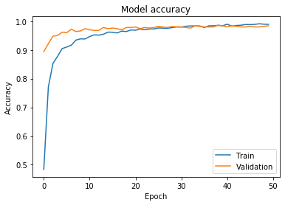 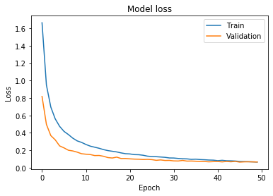

|  |  |  |  |  |  |  |  |  |  |
| --- | --- | --- | --- | --- | --- | --- | --- | --- | --- |
| 50 | 0 | 0 | 0 | 0 | 0 | 0 | 0 | 0 | 0 |
| 0 | 50 | 0 | 0 | 0 | 0 | 0 | 0 | 0 | 0 |
| 0 | 0 | 50 | 0 | 0 | 0 | 0 | 0 | 0 | 0 |
| 0 | 0 | 0 | 50 | 0 | 0 | 0 | 0 | 0 | 0 |
| 0 | 0 | 0 | 0 | 50 | 0 | 0 | 0 | 0 | 0 |
| 0 | 0 | 0 | 0 | 0 | 50 | 0 | 0 | 0 | 0 |
| 0 | 0 | 0 | 0 | 0 | 0 | 50 | 0 | 0 | 0 |
| 0 | 0 | 0 | 0 | 0 | 0 | 0 | 50 | 0 | 0 |
| 0 | 0 | 0 | 0 | 0 | 0 | 0 | 2 | 48 | 0 |
| 0 | 0 | 0 | 0 | 0 | 0 | 0 | 2 | 1 | 47 |

**mobilenet_v2_zoom**

Train: 99.90, Val: 98.2, Test: 98.2

 

|  |  |  |  |  |  |  |  |  |  |
| --- | --- | --- | --- | --- | --- | --- | --- | --- | --- |
| 50 | 0 | 0 | 0 | 0 | 0 | 0 | 0 | 0 | 0 |
| 0 | 50 | 0 | 0 | 0 | 0 | 0 | 0 | 0 | 0 |
| 0 | 0 | 50 | 0 | 0 | 0 | 0 | 0 | 0 | 0 |
| 0 | 0 | 0 | 50 | 0 | 0 | 0 | 0 | 0 | 0 |
| 0 | 0 | 0 | 0 | 50 | 0 | 0 | 0 | 0 | 0 |
| 0 | 0 | 0 | 0 | 0 | 48 | 0 | 0 | 0 | 2 |
| 0 | 0 | 0 | 0 | 0 | 0 | 50 | 0 | 0 | 0 |
| 0 | 0 | 0 | 0 | 0 | 0 | 0 | 49 | 0 | 1 |
| 0 | 0 | 0 | 0 | 0 | 0 | 0 | 2 | 48 | 0 |
| 0 | 0 | 0 | 0 | 0 | 0 | 0 | 3 | 1 | 46 |

**mobilenet_v2_shear**

Train: 100, Val: 98.40, Test: 98.6

 

|  |  |  |  |  |  |  |  |  |  |
| --- | --- | --- | --- | --- | --- | --- | --- | --- | --- |
| 50 | 0 | 0 | 0 | 0 | 0 | 0 | 0 | 0 | 0 |
| 0 | 50 | 0 | 0 | 0 | 0 | 0 | 0 | 0 | 0 |
| 0 | 0 | 50 | 0 | 0 | 0 | 0 | 0 | 0 | 0 |
| 0 | 0 | 0 | 50 | 0 | 0 | 0 | 0 | 0 | 0 |
| 0 | 0 | 0 | 0 | 50 | 0 | 0 | 0 | 0 | 0 |
| 0 | 0 | 0 | 0 | 0 | 49 | 0 | 0 | 0 | 1 |
| 0 | 0 | 0 | 0 | 0 | 0 | 50 | 0 | 0 | 0 |
| 0 | 0 | 0 | 0 | 0 | 0 | 0 | 50 | 0 | 0 |
| 0 | 0 | 0 | 0 | 0 | 0 | 0 | 3 | 47 | 0 |
| 0 | 0 | 0 | 0 | 0 | 0 | 0 | 2 | 1 | 47 |

**ImageDataGen**

**resnet_50_horizontal_flip**

Train: 100, Val: 98.6, Test: 98.8

 

|  |  |  |  |  |  |  |  |  |  |
| --- | --- | --- | --- | --- | --- | --- | --- | --- | --- |
| 50 | 0 | 0 | 0 | 0 | 0 | 0 | 0 | 0 | 0 |
| 0 | 50 | 0 | 0 | 0 | 0 | 0 | 0 | 0 | 0 |
| 0 | 0 | 50 | 0 | 0 | 0 | 0 | 0 | 0 | 0 |
| 0 | 0 | 0 | 50 | 0 | 0 | 0 | 0 | 0 | 0 |
| 0 | 0 | 0 | 0 | 50 | 0 | 0 | 0 | 0 | 0 |
| 0 | 0 | 0 | 0 | 0 | 49 | 0 | 0 | 0 | 1 |
| 0 | 0 | 0 | 0 | 0 | 0 | 50 | 0 | 0 | 0 |
| 0 | 0 | 0 | 0 | 0 | 0 | 0 | 50 | 0 | 0 |
| 0 | 0 | 0 | 0 | 0 | 0 | 0 | 2 | 48 | 0 |
| 0 | 0 | 0 | 0 | 0 | 0 | 0 | 2 | 1 | 47 |

**resnet_50_vertical_flip**

Train: 99.95, Val: 98.20, Test: 97.8

 

|  |  |  |  |  |  |  |  |  |  |
| --- | --- | --- | --- | --- | --- | --- | --- | --- | --- |
| 50 | 0 | 0 | 0 | 0 | 0 | 0 | 0 | 0 | 0 |
| 0 | 50 | 0 | 0 | 0 | 0 | 0 | 0 | 0 | 0 |
| 0 | 0 | 50 | 0 | 0 | 0 | 0 | 0 | 0 | 0 |
| 0 | 0 | 0 | 50 | 0 | 0 | 0 | 0 | 0 | 0 |
| 0 | 0 | 0 | 0 | 50 | 0 | 0 | 0 | 0 | 0 |
| 0 | 0 | 0 | 0 | 0 | 49 | 0 | 0 | 0 | 1 |
| 0 | 0 | 0 | 0 | 0 | 0 | 50 | 0 | 0 | 0 |
| 0 | 0 | 0 | 0 | 0 | 0 | 0 | 49 | 0 | 1 |
| 0 | 0 | 0 | 0 | 0 | 0 | 0 | 4 | 46 | 0 |
| 0 | 0 | 0 | 0 | 0 | 0 | 0 | 4 | 1 | 45 |

**resnet_50_width_shift**

Train: 100, Val: 99.2, Test: 98.4

 

|  |  |  |  |  |  |  |  |  |  |
| --- | --- | --- | --- | --- | --- | --- | --- | --- | --- |
| 50 | 0 | 0 | 0 | 0 | 0 | 0 | 0 | 0 | 0 |
| 0 | 50 | 0 | 0 | 0 | 0 | 0 | 0 | 0 | 0 |
| 0 | 0 | 50 | 0 | 0 | 0 | 0 | 0 | 0 | 0 |
| 0 | 0 | 0 | 50 | 0 | 0 | 0 | 0 | 0 | 0 |
| 0 | 0 | 0 | 0 | 50 | 0 | 0 | 0 | 0 | 0 |
| 0 | 0 | 0 | 0 | 0 | 50 | 0 | 0 | 0 | 0 |
| 0 | 0 | 2 | 0 | 0 | 0 | 48 | 0 | 0 | 0 |
| 0 | 0 | 0 | 0 | 0 | 0 | 0 | 48 | 1 | 1 |
| 0 | 0 | 0 | 0 | 0 | 0 | 0 | 2 | 48 | 0 |
| 0 | 0 | 0 | 0 | 0 | 0 | 0 | 2 | 0 | 48 |

**resnet_50_height_shift**

Train: 100, Val: 99, Test: 98

 

|  |  |  |  |  |  |  |  |  |  |
| --- | --- | --- | --- | --- | --- | --- | --- | --- | --- |
| 50 | 0 | 0 | 0 | 0 | 0 | 0 | 0 | 0 | 0 |
| 0 | 50 | 0 | 0 | 0 | 0 | 0 | 0 | 0 | 0 |
| 0 | 0 | 50 | 0 | 0 | 0 | 0 | 0 | 0 | 0 |
| 0 | 0 | 0 | 50 | 0 | 0 | 0 | 0 | 0 | 0 |
| 0 | 0 | 0 | 0 | 50 | 0 | 0 | 0 | 0 | 0 |
| 0 | 0 | 0 | 0 | 0 | 50 | 0 | 0 | 0 | 0 |
| 0 | 0 | 2 | 0 | 0 | 0 | 48 | 0 | 0 | 0 |
| 0 | 0 | 0 | 0 | 0 | 0 | 0 | 47 | 0 | 3 |
| 0 | 0 | 0 | 0 | 0 | 1 | 0 | 1 | 47 | 1 |
| 0 | 0 | 0 | 0 | 0 | 0 | 0 | 2 | 0 | 48 |

**resnet_50_rotation_shift**

Train: 100, Val: 99, Test: 98.4

 

|  |  |  |  |  |  |  |  |  |  |
| --- | --- | --- | --- | --- | --- | --- | --- | --- | --- |
| 50 | 0 | 0 | 0 | 0 | 0 | 0 | 0 | 0 | 0 |
| 0 | 50 | 0 | 0 | 0 | 0 | 0 | 0 | 0 | 0 |
| 0 | 0 | 50 | 0 | 0 | 0 | 0 | 0 | 0 | 0 |
| 0 | 0 | 0 | 50 | 0 | 0 | 0 | 0 | 0 | 0 |
| 0 | 0 | 0 | 0 | 50 | 0 | 0 | 0 | 0 | 0 |
| 0 | 0 | 0 | 0 | 0 | 50 | 0 | 0 | 0 | 0 |
| 0 | 0 | 1 | 0 | 0 | 0 | 49 | 0 | 0 | 0 |
| 0 | 0 | 0 | 0 | 0 | 0 | 0 | 48 | 0 | 2 |
| 0 | 0 | 0 | 0 | 0 | 0 | 0 | 1 | 48 | 1 |
| 0 | 0 | 0 | 0 | 0 | 0 | 0 | 3 | 0 | 47 |

**resnet_50_brightness**

Train: 99.90, Val: 97.80, Test: 96

 

|  |  |  |  |  |  |  |  |  |  |
| --- | --- | --- | --- | --- | --- | --- | --- | --- | --- |
| 50 | 0 | 0 | 0 | 0 | 0 | 0 | 0 | 0 | 0 |
| 0 | 50 | 0 | 0 | 0 | 0 | 0 | 0 | 0 | 0 |
| 0 | 0 | 48 | 0 | 0 | 0 | 2 | 0 | 0 | 0 |
| 0 | 0 | 0 | 50 | 0 | 0 | 0 | 0 | 0 | 0 |
| 0 | 0 | 0 | 0 | 50 | 0 | 0 | 0 | 0 | 0 |
| 0 | 0 | 0 | 0 | 0 | 50 | 0 | 0 | 0 | 0 |
| 0 | 0 | 3 | 0 | 0 | 0 | 47 | 0 | 0 | 0 |
| 0 | 0 | 0 | 0 | 0 | 0 | 0 | 47 | 0 | 3 |
| 0 | 0 | 0 | 1 | 0 | 0 | 1 | 3 | 42 | 3 |
| 0 | 0 | 0 | 0 | 0 | 0 | 0 | 4 | 0 | 46 |

**resnet_50_zoom**

Train: 99.95, Val: 98.8, Test: 99

 

|  |  |  |  |  |  |  |  |  |  |
| --- | --- | --- | --- | --- | --- | --- | --- | --- | --- |
| 50 | 0 | 0 | 0 | 0 | 0 | 0 | 0 | 0 | 0 |
| 0 | 50 | 0 | 0 | 0 | 0 | 0 | 0 | 0 | 0 |
| 0 | 0 | 50 | 0 | 0 | 0 | 0 | 0 | 0 | 0 |
| 0 | 0 | 0 | 50 | 0 | 0 | 0 | 0 | 0 | 0 |
| 0 | 0 | 0 | 0 | 50 | 0 | 0 | 0 | 0 | 0 |
| 0 | 0 | 0 | 0 | 0 | 50 | 0 | 0 | 0 | 0 |
| 0 | 0 | 0 | 0 | 0 | 0 | 50 | 0 | 0 | 0 |
| 0 | 0 | 0 | 0 | 0 | 0 | 0 | 47 | 1 | 2 |
| 0 | 0 | 0 | 0 | 0 | 0 | 0 | 1 | 49 | 0 |
| 0 | 0 | 0 | 0 | 0 | 0 | 0 | 1 | 0 | 49 |

**resnet_50_shear**

Train: 100, Val: 99.0, Test: 98.8

 

|  |  |  |  |  |  |  |  |  |  |
| --- | --- | --- | --- | --- | --- | --- | --- | --- | --- |
| 50 | 0 | 0 | 0 | 0 | 0 | 0 | 0 | 0 | 0 |
| 0 | 50 | 0 | 0 | 0 | 0 | 0 | 0 | 0 | 0 |
| 0 | 0 | 50 | 0 | 0 | 0 | 0 | 0 | 0 | 0 |
| 0 | 0 | 0 | 50 | 0 | 0 | 0 | 0 | 0 | 0 |
| 0 | 0 | 0 | 0 | 50 | 0 | 0 | 0 | 0 | 0 |
| 0 | 0 | 0 | 0 | 0 | 50 | 0 | 0 | 0 | 0 |
| 0 | 0 | 1 | 0 | 0 | 0 | 49 | 0 | 0 | 0 |
| 0 | 0 | 0 | 0 | 0 | 0 | 0 | 49 | 0 | 1 |
| 0 | 0 | 0 | 0 | 0 | 0 | 0 | 2 | 48 | 0 |
| 0 | 0 | 0 | 0 | 0 | 0 | 0 | 2 | 0 | 48 |

**Original**

|  |  |
| --- | --- |
| **Model** | **Accuracy** |
| inception_v3 | Train: 100, Val: 96.80, Test: 95.40 |
| mobilenet_v2 | Train: 100, Val: 98.40, Test: 98 |
| ResNet 50 | Train: 100, Val: 99, Test: 98.4 |

**Ensemble**

|  |  |
| --- | --- |
| **Model** | **Accuracy** |
| inception_v3 | Train: 100, Val: 97.4, Test: 96.40 |
| mobilenet_v2 | Train: 100, Val: 98.40, Test: 98.8 |
| ResNet 50 | Train: 100, Val: 99, Test: 98.4 |

**GAN**

|  |  |
| --- | --- |
| **Model** | **Accuracy** |
| inception_v3 | Train: 99.80, Val: 96.80, Test: 94 |
| mobilenet_v2 | Train: 99.86, Val: 98.60, Test: 98.4 |
| ResNet 50 | Train: 100, Val: 99.2, Test: 98 |

**DataGen**

|  |  |  |
| --- | --- | --- |
| **Type** | **Model** | **Accuracy** |
| horizontal_flip | inception_v3 | Train: 100, Val: 97.80, Test: 96.20 |
| mobilenet_v2 | Train: 100, Val: 98.6, Test: 98.8 |
| ResNet 50 | Train: 100, Val: 98.6, Test: 98.8 |
| vertical_flip | inception_v3 | Train: 100, Val: 97.20, Test: 95.6 |
| mobilenet_v2 | Train: 99.95, Val: 98.20, Test: 97.8 |
| ResNet 50 | Train: 99.95, Val: 98.20, Test: 97.8 |
| width_shift | inception_v3 | Train: 100, Val: 97.40, Test: 96.2 |
| mobilenet_v2 | Train: 99.95, Val: 98.6, Test: 98.8 |
| ResNet 50 | Train: 100, Val: 99.2, Test: 98.4 |
| height_shift | inception_v3 | Train: 98.90, Val: 96.8, Test: 94.8 |
| mobilenet_v2 | Train: 99.85, Val: 98.6, Test: 98 |
| ResNet 50 | Train: 100, Val: 99, Test: 98 |
| rotation_shift | inception_v3 | Train: 99.50, Val: 97, Test: 95 |
| mobilenet_v2 | Train: 99.95, Val: 98.6, Test: 98.6 |
| ResNet 50 | Train: 100, Val: 99, Test: 98.4 |
| brightness | inception_v3 | Train: 96, Val: 94, Test: 92.4 |
| mobilenet_v2 | Train: 98.90, Val: 98.40, Test: 99 |
| ResNet 50 | Train: 99.90, Val: 97.80, Test: 96 |
| zoom | inception_v3 | Train: 99.20, Val: 95.80, Test: 95.6 |
| mobilenet_v2 | Train: 99.90, Val: 98.2, Test: 98.2 |
| ResNet 50 | Train: 99.95, Val: 98.8, Test: 99 |
| shear | inception_v3 | Train: 99.95, Val: 96.40, Test: 95.2 |
| mobilenet_v2 | Train: 100, Val: 98.40, Test: 98.6 |
| ResNet 50 | Train: 100, Val: 99.0, Test: 98.8 |

**Increment**

|  |  |  |
| --- | --- | --- |
| **Model** | **Aug** | **Accuracy** |
| inception_v3 | 1 | Train: 100, Val: 97.4, Test: 96.40 |
|  | 2 | Train: 100, Val: 97.2, Test: 96.40 |
|  | 3 | Train: 100, Val: 97.4, Test: 96.4 |
|  | 4 | Train: 100, Val: 97.4, Test: 96.40 |
|  | 5 | Train: 100, Val: 97.60 Test: 96.20 |
| mobilenet_v2 | 1 | Train: 100, Val: 98.40, Test: 98.8 |
|  | 2 | Train: 100, Val: 98.60, Test: 98.6 |
|  | 3 | Train: 100, Val: 98.60, Test: 98.6 |
|  | 4 | Train: 100, Val: 98.60, Test: 98.6 |
|  | 5 | Train: 100, Val: 98.60, Test: 98.6 |
| ResNet 50 | 1 | Train: 100, Val: 99, Test: 98.4 |
|  | 2 | Train: 100, Val: 99.4, Test: 98.6 |
|  | 3 | Train: 100, Val: 99.4, Test: 99.2 |
|  | 4 | Train: 100, Val: 99.4, Test: 99.2 |
|  | 5 | Train: 100, Val: 99.4, Test: 99 |

|  |  |  |
| --- | --- | --- |
| **Model** | **GAN** | **Accuracy** |
| inception_v3 | 1 | Train: 99.80, Val: 96.80, Test: 94 |
|  | 2 | Train: 99.68, Val: 95.80, Test: 95.20 |
|  | 3 | Train: 99.08, Val: 96, Test: 94.4 |
|  | 4 | Train: 98.70, Val: 95.80, Test: 94.6 |
|  | 5 | Train: 98.9, Val: 95.0, Test: 94.6 |
| mobilenet_v2 | 1 | Train: 99.86, Val: 98.60, Test: 98.4 |
|  | 2 | Train: 99.83, Val: 98.40, Test: 98.2 |
|  | 3 | Train: 99.87, Val: 98.40, Test: 98 |
|  | 4 | Train: 99.76, Val: 98.60, Test: 97.8 |
|  | 5 | Train: 99.92, Val: 98.40, Test: 98.4 |
| ResNet 50 | 1 | Train: 100, Val: 99.2, Test: 98 |
|  | 2 | Train: 99.97, Val: 99.2, Test: 97.8 |
|  | 3 | Train: 99.80, Val: 98.80, Test: 98 |
|  | 4 | Train: 99.96, Val: 98.60, Test: 97.8 |
|  | 5 | Train: 99.92, Val: 98.80, Test: 98.2 |

|  |  |  |
| --- | --- | --- |
| **Model** | **DataGen_Combined** | **Accuracy** |
| inception_v3 | 1 | Train: 99.80, Val: 96.80, Test: 94 |
|  | 2 | Train: 99.68, Val: 95.80, Test: 95.20 |
|  | 3 | Train: 99.08, Val: 96, Test: 94.4 |
|  | 4 | Train: 98.70, Val: 95.80, Test: 94.6 |
|  | 5 | Train: 98.9, Val: 95.0, Test: 94.6 |
| mobilenet_v2 | 1 | Train: 99.86, Val: 98.60, Test: 98.4 |
|  | 2 | Train: 99.83, Val: 98.40, Test: 98.2 |
|  | 3 | Train: 99.87, Val: 98.40, Test: 98 |
|  | 4 | Train: 99.76, Val: 98.60, Test: 97.8 |
|  | 5 | Train: 99.92, Val: 98.40, Test: 98.4 |
| ResNet 50 | 1 | Train: 99.95, Val: 98.0, Test: 96 |
|  | 2 | Train: 100, Val: 97.6, Test: 96 |
|  | 3 | Train: 100, Val: 97.6, Test: 96.8 |
|  | 4 | Train: 99.90, Val: 97, Test: 96 |
|  | 5 | Train: 99.95, Val: 97.4, Test: 96.2 |